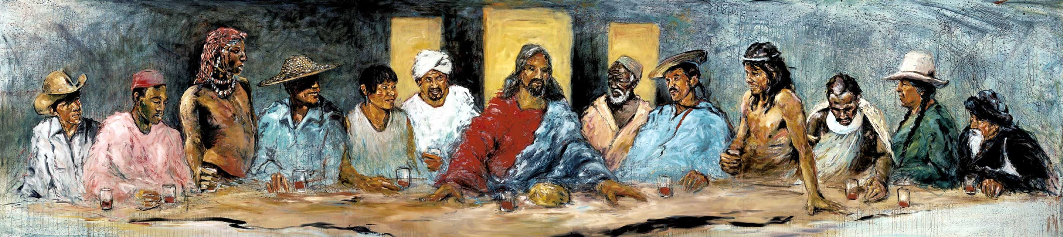
The artwork is the work of Christian artist, Hyatt Moore. He painted it for a mission conference in British Columbia in 2000 to commemorate the inclusion of all peoples under God. Depicted (from left) are: Crow of Montana, Berber of North Africa, Masai of Kenya,
China, Ecuador, Afghanistan, Jesus, Ethiopia, Tzeltal of Mexico, Canela of Brazil, Papua New Guinea, Salish of British Columbia, Mongolia. The Last Supper with Twelve Tribes, acrylic and oil on canvas, 20 ft. x 4 ft. 6in. His art can be found at http://www.hyattmoore.com

ORDER FOR THE WORSHIP OF GOD
October 1, 2017 World Communion 8:30 & 9:45 A.M.

PRELUDE This Is My Father’s World arr. Olstad

WELCOME (Please sign and pass the Friendship Pad in your pew.)

MINUTE FOR STEWARDSHIP Angela Emrich

CHORAL INTROIT Praise Ye the Lord! Clausen

CALL TO WORSHIP: (from Luke 13:29-30 & Ephesians 4:5)

Leader: People will come from east and west, from north and south, and will eat in the kingdom of God.

People: Some who are last will be first, and some who are first will be last.

Leader: Today we gather around God's table from near and far.

People: Though we differ in language, custom and tradition, we are brothers and sisters in Christ!

Leader: For there is one Lord, one faith, and one baptism

People: We are One in God's Spirit! Come, let us worship the God of our Salvation!

HYMN #265 Jesus Shall Reign Where’er the Sun (stand if able)

UNISON PRAYER OF CONFESSION
God, our fears and prejudices run deep. Sometimes we can only see our own point of view. We stick with those who are like us, rarely venturing outside our comfort zones. We do not hear those crying for justice and true peace. We blame those who are suffering and in need, instead of standing with them. We deny the power of Your gospel to unite us with those who are different from us. Give us eyes to see and ears to hear. Open us to building community with all of Your people and to living out the new life given us in Christ. (time for silent prayers of confession).

ASSURANCE OF PARDON
Pastor: Friends, believe the good news of the gospel.
People: In Jesus Christ we are forgiven.
GLORIA PATRI (please stand if able)

Glory be to the Father, and to the Son and to the Holy Ghost. As it was in the beginning, is now and ever shall be. World without end. Amen, Amen.

AFFIRMATION OF FAITH (adapted from the Belhar Confession)
(please stand if able)

We believe in one holy, universal Christian church,
the unity of the communion of saints of the entire human family. And we believe this unity of the people of God
must be manifest and active,
in that we love one another;
that we give ourselves willingly and joyfully to one another,
that we share one baptism together,
that we eat of one bread and drink of one cup together,
that we confess one name, one Lord, one cause, with one hope, which is the height and the breadth and the depth
and the love of Christ, forever and ever. Amen.

THOUGHT FOR CHILDREN (9:45 only)

CONGREGATIONAL GREETING – “The Peace of Christ”

PASTORAL PRAYER AND THE LORD’S PRAYER

……….Our Father, who art in heaven, hallowed be Thy name. Thy kingdom come, Thy will be done, on earth as it is in heaven. Give us this day our daily bread, and forgive us our debts, as we forgive our debtors, and lead us not into temptation, but deliver us from evil, for Thine is the kingdom, and the power and the glory forever, Amen.

OFFERTORY This Is My Father’s World arr. Hagenberg

DOXOLOGY (please stand if able)

Praise God from whom all blessings flow. Praise Him all creatures here below. Praise Him above ye heavenly hosts. Praise Father, Son and Holy Ghost. Amen.
UNISON PRAYER OF DEDICATION
(Today we dedicate our Peace and Global Witness Offering)

Loving and gracious God, we offer these gifts to You to do good in the world. May they help us to build community and discern the ways in which You would have us break down the dividing walls and boundaries that separate people, as we seek to erase hostilities and bring peace. In Jesus’ name, we pray. Amen. (please be seated)

SCRIPTURE LESSON Philippians 2:1-13 (Pew Bible pg. 954)
Kathy Smedley

Pastor: The Word of the Lord.
People: Thanks be to God.

MEDITATION “Be the Church - Build Community” Jennie Clark

SACRAMENT OF COMMUNION

Invitation
Prayer of Thanksgiving

Pastor: The Lord be with you.
People: And also with you.
Pastor: Lift up your hearts.
People: We lift them up to the Lord.
Pastor: Let us give thanks to the Lord our God.
People: It is right to give thanks and praise.

Words of Institution
Sharing the Bread and Cup (please hold until all have been served)
Communion Prayer

HYMN #372 O for a World (stand if able)

BENEDICTION

POSTLUDE God of Grace and God of Glory arr. Held

  Worship Times:  8:30 a.m.  9:45 a.m.  11:10 a.m. | WELCOME VISITORS! We are glad you are here today. To help us welcome you personally, please sign the Friendship Pad with your name, address, email and/or phone number.  You will find literature about Westminster at the Information Center. If you are interested in knowing more about being a follower of Jesus, have any questions, or desire follow-up information, please speak to one of the pastors. Following worship they can be found greeting at the doors of the sanctuary.  The next new members class is Sunday, October 15, 11:00-3:30 p.m. Childcare available during class.

LECTIONARY PASSAGES FOR TODAY are: Exodus 17:1-7; Psalm 78:1-4, 12-16; Philippians 2:1-13; Matthew 21:23-32. In addition to Sunday readings, there are lectionary readings for every day. Go to www.westminsterpc.org/grow/spiritual-practices/daily-lectionary to the box called “Lectionary Reading” and click on the date.

The flowers on the pedestals are given by Gary and Nancy Christy in loving memory of their parents, Wayne and Virginia Christy and Harold and Myrtle Beecher. The ADDITIONAL FLOWERS in the sanctuary are from the memorial service on Saturday for Leon Talmage.

The SACRAMENT OF HOLY COMMUNION is celebrated this morning during worship. All who believe in Jesus Christ, together with their baptized children are welcome to receive communion.

USHERS 8:30 A.M.: Scott Seymour (head usher), Bob Barcus, Steve Murphy

USHERS 9:45 A.M: Kevin Chapman (head usher), Jenn Armstrong, Tom Armstrong, Ross Feehrer, Andie DeVries, Jack DeVries, Tim Krenz, Sue Puffer

GREETERS 8:30 A.M.: Lynn Carrero; Nancy Latham

GREETERS 9:45 A.M.: Deb and Ev Randall; Grace McCord

ADULT SPIRITUAL GROWTH opportunities TODAY:
- 9:45 a.m. in the Chapel. Academy Class, Money, Love, and Wine: Desire and the Moral Life led by Anne W. Stewart
- 9:45 a.m. in Spellman Jr. Veterans Group, How Can History Help the Present, led by Dr. Michael Neiburg.

KIDS CONNECT LEARN AND SERVE
- 8:30am: Childcare for infants through 4 years of age.
- 9:45am: Childcare for infants through 3 years of age; Sunday
school for 4 years old through 5th grade.
- 11:10am: Large group combined Kindergarten through 5th grade.

MIDDLE SCHOOL SUNDAY SCHOOL at 9:45am in The Site.

THE THREAD for 9th 12th graders begins at 9:45 in The Cove.

WORSHIP INFORMATION

WEEKLY WORSHIP SCHEDULE

Sanctuary
8:30am – Traditional worship with choir (except July/August)
9:45am – Traditional worship with choir (except August)
11:10am – Contemporary worship with band

Chapel Service on Wednesday
9:10-9:30am – Prayer and Communion service

CHILDCARE FOR INFANTS AND TODDLERS is available at all Sunday morning services. BULLETINS FOR CHILDREN, LARGE PRINT BULLETINS AND HYMNALS, AND SPANISH AND KOREAN BIBLES are available from ushers or located on shelves above the coat racks.

A REMOTE TV MONITOR is in the church parlor (just outside the sanctuary in the west hallway) to view and hear worship in progress for those with restless children or who need to leave the sanctuary.

HEARING ASSISTANCE DEVICES are available for worship at the Information Center in the Narthex. Additionally, the sanctuary is equipped with an induction loop system that transmits to hearing aids and cochlear implants with telecoils. PEW CUSHIONS also available at the Information Center.

LIVE STREAMING of our 9:45 a.m. traditional worship is now being offered over the internet. We invite you to join us at westminsterpc.org when not able to attend worship.

text giving is available. You can give via your phone; it’s easy, secure and instant. Start a new text message to 610-616-2826. Enter the dollar amount of your gift as the text. Send. First time givers are prompted to a link to enter credit/debit card information.

TAIZÉ PRAYER in the Chapel and contemplative worship occurs various times throughout the program year. Visit our website or call 610-399-3377 for dates and times.

PRAYER CHAIN members receive a weekly list of prayer requests via email and members include them in their conversations with God. To have a prayer request included in the Prayer Chain or to become a member, contact Jeanne Klaver at jeanneklaver@gmail.com or the church office.

THE SACRAMENT OF COMMUNION is celebrated the first Sunday of every month in all services. If you desire or know of someone desiring HOME COMMUNION, please contact Ann Hatfield, Associate Pastor for Pastoral Care at 610-399-3377 ext. 114.

THE SACRAMENT OF BAPTISM is celebrated the third Sunday of every month. Our BAPTISM CLASS is offered the last Sunday of each month, except December, at 11:00am in the Chapel. Contact the office to register for the baptism class.

TRANSCRIPTS OF PREVIOUS SERMONS can be found on the table in the narthex just outside the sanctuary center doors. Audio and text versions available online at www.westminsterpc.org.
WESTMINSTER PRESBYTERIAN CHURCH

October 1, 2017
WORLD COMMUNION SUNDAY
8:30 and 9:45 A.M. Traditional
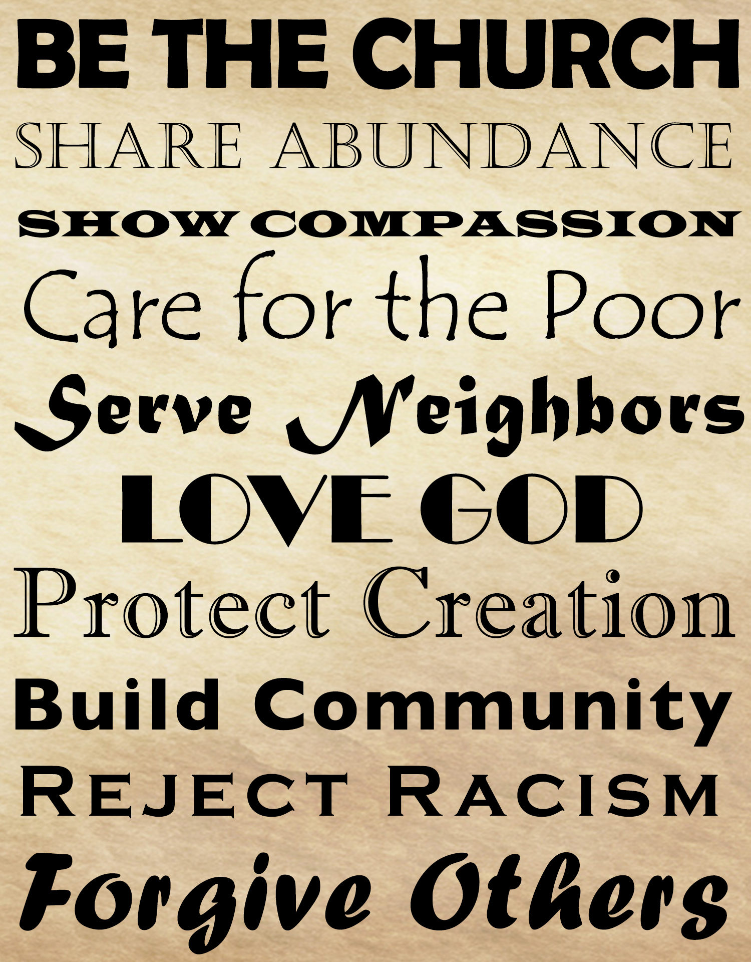

GATHERING THOUGHT

There are times in our lives when we grasp at once how vital unity is. It may be during a meal with friends or else at a family gathering when we see all present conversing and happy to be in one another’s company. Past differences or misunderstandings may not have totally vanished but they lose their strength and importance as the bonds of shared affection are celebrated. Such experiences are privileged moments. Unity becomes a living reality. And we realize that it is a gift, perhaps the greatest of all gifts, one which we in fact desire deeply and which gives us an unsurpassed joy.

-From a Taize Community Reflection on Philippians 2:1-5

