ORDER FOR THE WORSHIP OF GOD
Christ the King Sunday
November 26, 2017 8:30 & 9:45 A.M.

PRELUDE Fantasia on “Holy, Holy, Holy” Post

WELCOME (Please sign and pass the Friendship Pad in your pew.)

CHORAL INTROIT Praise Ye The Lord Clausen

All that hath life and breath praise ye the Lord, shout to the Lord, Alleluia!

CALL TO WORSHIP (from Psalm 100: 1-5) Joey Brun (9:45)

Leader: Make a joyful noise to the LORD, all the earth.

People: Worship the LORD with gladness; come into His presence with singing.

Leader: Know that the LORD is God.

People: It is He that made us, and we are His; we are His people, and the sheep of His pasture.

Leader: Enter His gates with thanksgiving, and His courts with praise.

People: Give thanks to Him, bless His name.

Leader: For the LORD is good;

People: His steadfast love endures forever, and His faithfulness to all generations.

HYMN #267 Come, Christians, Join to Sing (please stand if able)

UNISON PRAYER OF CONFESSION

Sovereign God, we confess that we are not ready for your holy realm. You guide us toward right paths, but we refuse to follow where you lead. You love and feed and care for us, but we fail to love and serve others. Forgive us, merciful God, so that we may return to your fold and rejoice in your presence; through Jesus Christ our Lord, the Lamb upon the throne….…....(time for us to offer silent prayers of confession).

ASSURANCE OF PARDON

Pastor: Friends, believe the good news of the gospel.
People: In Jesus Christ we are forgiven.

GLORIA PATRI (please stand if able)

Glory be to the Father, and to the Son and to the Holy Ghost. As it was in the beginning, is now and ever shall be. World without end. Amen, Amen.

APOSTLES’ CREED (please stand if able) Joey Brun (9:45)

I believe in God the Father Almighty, Maker of heaven and earth, and in Jesus Christ His only Son our Lord, who was conceived by the Holy Ghost, born of the Virgin Mary, suffered under Pontius Pilate, was crucified, dead and buried; He descended into hell; the third day He rose again from the dead; He ascended into heaven, and sitteth on the right hand of God the Father Almighty; from thence He shall come to judge the quick and the dead. I believe in the Holy Ghost, the holy catholic church, the communion of saints, the forgiveness of sins, the resurrection of the body, and the life everlasting. Amen.

THOUGHT FOR CHILDREN (9:45 only)

CONGREGATIONAL GREETING – “The Peace of Christ”

PASTORAL PRAYER AND THE LORD'S PRAYER

……….Our Father, who art in heaven, hallowed be Thy name. Thy kingdom come, Thy will be done, on earth as it is in heaven. Give us this day our daily bread, and forgive us our debts, as we forgive our debtors, and lead us not into temptation, but deliver us from evil, for Thine is the kingdom, and the power and the glory forever, Amen.

OFFERTORY The Heavens Are Telling Haydn
From The Creation
Sextet: Gloria Ballinger, Mark Banghart, Dave Carpenter
Karen Evans, Steve Pymer, Bob Steiginga

The heavens are telling the glory of God, the wonder of His work displays the firmament. The wonder of His work displays the firmament.

Today that is coming speaks it the day, the night that is gone to following night; the night that is gone to following night. The heavens are telling the glory of God, the wonder of His work displays the firmament. The wonder of His work displays the firmament.

In all the lands resounds the word, never unperceived, ever understood, ever, ever, ever understood. In all the lands resound the word, never unperceived, ever understood, ever, ever, ever understood. The heavens are telling the glory of God, the wonder of His work displays the firmament. The wonder of His work displays the firmament.
DOXOLOGY (please stand if able)

Praise God from whom all blessings flow. Praise Him all creatures here below. Praise Him above ye heavenly hosts. Praise Father, Son and Holy Ghost. Amen.

UNISON PRAYER OF DEDICATION

Holy God, use us and these gifts to feed the hungry, clothe the naked, and honor Your presence in all people, through Jesus Christ our Lord. Amen. (please be seated)

FIRST SCRIPTURE LESSON Ezekiel 34: 11-16, 20-24
(Pew Bible 702)

SECOND SCRIPTURE LESSON Ephesians 1: 15-23 (Pew Bible 949)

Pastor: The Word of the Lord.
People: Thanks be to God.

SERMON “The Greatness of His Power” Jon Frost

HYMN#274 You, Lord, Are Both Lamb and Shepherd (stand if able)

BENEDICTION

POSTLUDE Finale and Hymn Post

  Worship Times:  8:30 a.m.  9:45 a.m.  11:10 a.m. | WELCOME VISITORS! We are glad you are here today. To help us welcome you personally, please sign the Friendship Pad with your name, address, email and/or phone number.  You will find literature about Westminster at the Information Center. If you are interested in knowing more about being a follower of Jesus, have any questions, or desire follow-up information, please speak to one of the pastors. Following worship they can be found greeting at the doors of the sanctuary.  The next New Members’ Class is Saturday, January 27, 2018, 9:00 a.m.-3:30 p.m. Childcare available during the class upon request.

LECTIONARY PASSAGES FOR TODAY are: Ezekiel 34:11-16, 20-24; Psalm 100; Ephesians 1:15-23; Matthew 25:31-46. In addition to Sunday readings, there are lectionary readings for every day. Go to www.westminsterpc.org/grow/spiritual-practices/daily-lectionary to the box called “Lectionary Reading” and click on the date.

The flowers on the pedestals are given by the Gambill Family in honor of Flora and Rhonda Greenwood.

THE RED ROSEBUD IN THE NICHE is in celebration of the birth of Sutton Cooper Mecouch on October 28. Sutton is the grandson of Roger and Suzanne Mecouch.

USHERS 9:45 A.M.: Steve Miller (head usher), Jim Hatfield, Bob Krauss, Mike Neesham, Nicole Neesham, Ann Stathopoulos, Dave Stilley

GREETERS 8:30 A.M.: Lynn Carrero
Bill Wilson

GREETERS 9:45 A.M.: Joan Ranieri
Grace McCord

ADULT SPIRITUAL GROWTH opportunities TODAY:
9:45 a.m. in the Chapel. The Gift of Gratitude, led by Ann Hatfield. In this season of thanksgiving, explore how we can cultivate an attitude of gratitude in ourselves. Discover how deepening our grateful response to God will increase the peace and joy in our lives.

KIDS CONNECT LEARN AND SERVE
- 8:30am: Childcare for infants through 4 years of age.
- 9:45am: Childcare for infants through 3 years of age; Sunday
school for 4 years old through 5th grade.
- 11:10am: Large group combined Kindergarten through 5th grade.

MIDDLE SCHOOL SUNDAY SCHOOL at 9:45am in The Site.

THE THREAD for 9th-12th graders at 9:45am in The Cove.

* * * * * * * * *

Ministers of Jesus Christ All the Members of the Congregation
Pastors Jennie Clark, Jon Frost, Ann Hatfield, Don Lincoln
Parish Associate Ed Brandt
Pastor Emeritus Robert Young
Director of Children and Families Ministry Sue Spotts
Director of Youth Chris Clark
Director of Music Bob Morris
Associate Director/Principal Organist Glenn Kinckner

Westminster Presbyterian Church
10 W. Pleasant Grove Road
West Chester, PA 19382 ♦ 610-399-3377
info@westminsterpc.org ♦ www.westminsterpc.org
WORSHIP INFORMATION

WEEKLY WORSHIP SCHEDULE

Sanctuary
8:30am – Traditional worship with choir (except July/August)
9:45am – Traditional worship with choir (except August)
11:10am – Contemporary worship with band

Chapel Service on Wednesday
9:10-9:30am – Prayer and Communion service

CHILDCARE FOR INFANTS AND TODDLERS is available at all Sunday morning services. BULLETINS FOR CHILDREN, LARGE PRINT BULLETINS AND HYMNALS, AND SPANISH AND KOREAN BIBLES are available from ushers or located on shelves above the coat racks.

A REMOTE TV MONITOR is in the church parlor (just outside the sanctuary in the west hallway) to view and hear worship in progress for those with restless children or who need to leave the sanctuary.

HEARING ASSISTANCE DEVICES are available for worship at the Information Center in the Narthex. Additionally, the sanctuary is equipped with an induction loop system that transmits to hearing aids and cochlear implants with telecoils. PEW CUSHIONS also available at the Information Center.

LIVE STREAMING of our 9:45 a.m. traditional worship is now being offered over the internet. We invite you to join us at westminsterpc.org when not able to attend worship.

text giving is available. You can give via your phone; it’s easy, secure and instant. Start a new text message to 610-616-2826. Enter the dollar amount of your gift as the text. Send. First time givers are prompted to a link to enter credit/debit card information.

TAIZÉ PRAYER in the Chapel and contemplative worship occurs various times throughout the program year. Visit our website or call 610-399-3377 for dates and times.

PRAYER CHAIN members receive a weekly list of prayer requests via email and members include them in their conversations with God. To have a prayer request included in the Prayer Chain or to become a member, contact Jeanne Klaver at jeanneklaver@gmail.com or the church office.

THE SACRAMENT OF COMMUNION is celebrated the first Sunday of every month in all services. If you desire or know of someone desiring HOME COMMUNION, please contact Ann Hatfield, Associate Pastor for Pastoral Care at 610-399-3377 ext. 114.

THE SACRAMENT OF BAPTISM is celebrated the third Sunday of every month. Our BAPTISM CLASS is offered the last Sunday of each month, except December, at 11:00am in the Chapel. Contact the office to register for the baptism class.

TRANSCRIPTS OF PREVIOUS SERMONS can be found on the table in the narthex just outside the sanctuary center doors. Audio and text versions available online at www.westminsterpc.org.

WESTMINSTER PRESBYTERIAN CHURCH

Knowing Christ…..Making Christ Known

November 26, 2017
8:30 and 9:45 A.M. Traditional

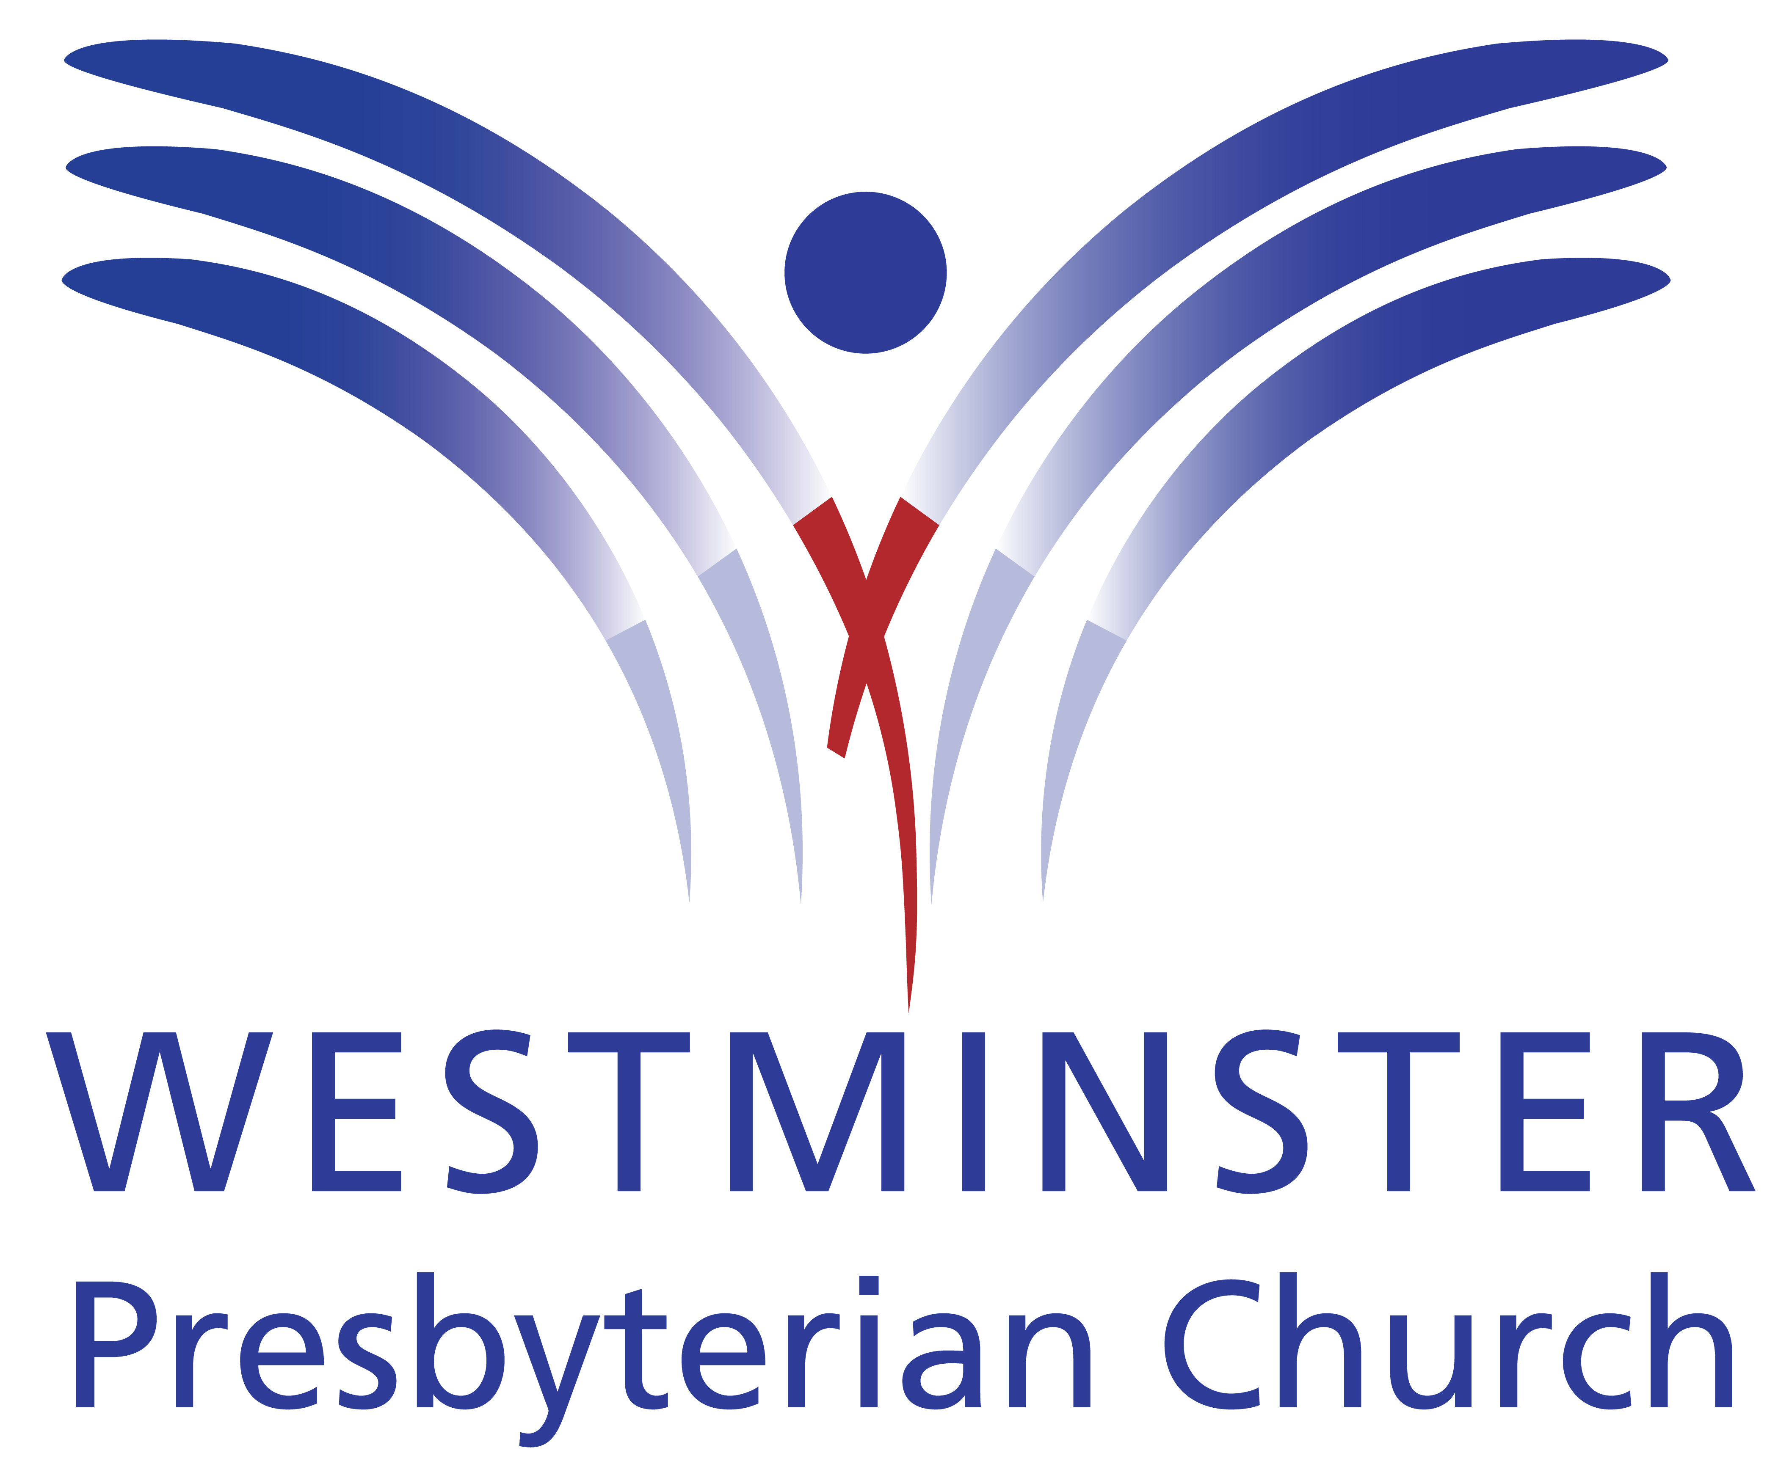

GATHERING THOUGHT

Worthy is our earthly Jesus!
Worthy is our cosmic Christ!
Worthy your defeat and victory;
worthy still your peace and strife.
You, the everlasting instant;
you, who are our death and life.

