Wisdom & Discernment

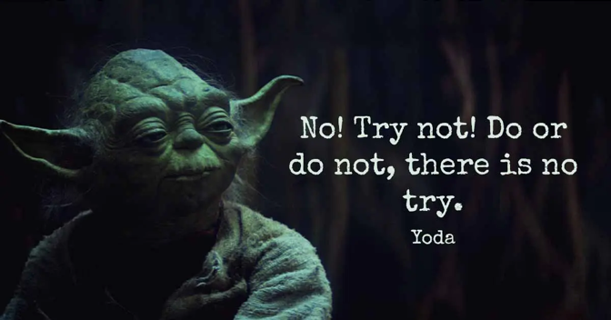
Opening Question: Write about a saying, movie, story, or song that inspires and motivates you. Why does it inspire and/or motivate you? What words of advice does it offer to you?

Whatever you shared in the above question, it probably has some kind of connection to wisdom. What comes to mind when you think of the word “wisdom”? Perhaps you imagine an old person with gray head of hair (or maybe Yoda?) or perhaps it sparks thoughts of ancient sayings or the attainment of knowledge. But wisdom isn’t simply about knowing lots of stuff – it’s not even about being old with gray hair! Let’s dive in to explore what wisdom really is and how you (yes even teenagers!) can grow in wisdom and discernment. In fact, let’s begin with a story about Jesus…
There aren’t many stories about Jesus as a kid or teenager in the Bible, but one of those stories is in Luke 2:41-52. This short story ends with “Jesus increased in wisdom”. Sometimes the way Christians talk about Jesus, it’s as if he was just automatically born wise since he was fully human and fully divine. But this story seems to show that Jesus had to learn from others just like any other human being – just like you! So read this story slowly, and perhaps a few times through. As you read and imagine the story in your mind, how does it show Jesus growing in wisdom? What is something that Jesus does in the story that is important for gaining or growing in wisdom?

Did you know that there is an entire section of the Bible known as “wisdom literature”? In fact, there are exactly three books in the Bible that focus on wisdom: Proverbs, Ecclesiastes and Job. Let’s spend some time with Proverbs. But before you read anything, take a moment to watch this video on Proverbs 8 - it will help give you some helpful background before reading some of the words of wisdom from this fascinating book of the Bible.
“Lady Wisdom”

After you have watched the video, take a moment to read Proverbs 1:1-7 and consider these questions:
- According to the video and the Proverbs passage, why does wisdom matter in the world?
- One might think that wisdom might mean that a person has lived their life without mistakes – that being a wise person means you’ve avoided mistakes and failures. Could it be possible that we may learn just as much or more from our failures than our successes in life? Why or why not?

If we can be gracious with ourselves, our shortcomings may help us grow in wisdom. Contemplate the two sentences below for a moment. On a scale of 1-10, circle a number based on how much you agree or disagree with these statements. Write why you circled that number. Next, ask a person in your life who you think is close to God (a family member, a coach, a teacher, a mentor, a neighbor, etc) who you think is wise, to give their answer based on a scale of 1-10. Ask them why they chose that number and write their answer down.

Wisdom comes from accepting everything in your life (success or failure) as a gift for your transformation into the likeness of Christ. Discernment helps you recognize the gift.

1 2 3 4 5 6 7 8 9 10

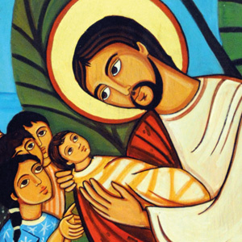
Sometimes teenagers and children can be looked down on because they are young. You may feel that way at times depending on what an adult has said or done to make you feel seen, heard, or respected. Sometimes what adults forget is that young people have wisdom to offer too! Jesus even taught that adults have something to learn from young people (Mark 10:15). You too are a part of God’s creation, into which wisdom has been woven. Having wisdom doesn’t mean you don’t have anything to learn – we are always growing – but don’t ever believe that you don’t have any wisdom to offer others .

- Ask a trusted adult in your life about the wisdom they see in you. Ask “How have you seen me grow in wisdom over the time you have known me?” Write down their response.
- How does their response make you feel? Find a place in your bedroom to keep their response as a reminder to yourself that you do carry God’s wisdom in you wherever you go.

Closing Prayer Practice - Breath Prayer

Inhale: May my life grow every day
Exhale: In the gifts of the Spirit

