Peacemaking and Unity

- Share about a time when you felt most at peace in your life. What was that like for you?

We would hope that the world can be more peaceful someday. That we might see a day where conflicts around the world cease, wars never happen, and no one is oppressed. Perhaps that feels a bit unrealistic. But isn’t that what we hope for? So how do we get there?

Well, as followers of Jesus, we are called to partner with God in Shalom – the Hebrew word for Peace. That’s a pretty familiar word to us, often referring to stillness, or tranquility. We might look out on a still lake or take a walk through the woods away from the noise of life and think “Ah, this is really peaceful.” But when it comes to Shalom, that stillness is only one part of the meaning. The word Shalom is more of an active seeking of goodness, and working toward a world where all people and creation flourish. As you’ll see in the prophets, God delights in peace and is deeply grieved and frustrated when it is absent. Watch this video on God’s Shalom.
Christian hope is focused on new creation when all things are made right. There is a prayer we pray each Sunday at church, and millions of Christians pray everyday around the world: The Lord’s Prayer. “Our Father who art in Heaven, hallowed be thy name. Thy kingdom come, thy will be done on earth as it is in heaven.” That line that millions of Christians pray every day is not about heaven but about the love, wisdom, justice, and compassion that Jesus practiced and preached becoming a reality on earth through people.

Read John 15:1-17 & Ephesians 4:1-6
- Jesus tells his disciples to “abide in my love”. Search the word “abide” in dictionary.com and search it on thesaurus.com. What definitions and words do you find for the meaning of that word? In light of what you find, what do you think it means to abide in Jesus love?
- The writer of Ephesians urges Christians to make “every effort to maintain the unity of the Spirit in the bod of peace.” Unity and peace require effort – they don’t happen magically. Who are some of the people who you see making efforts to bring unity and peace to the world or your community?

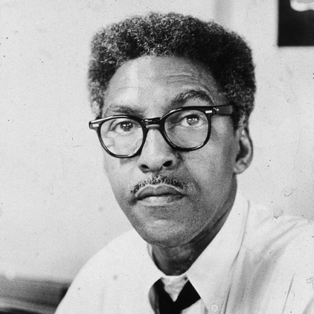
“We are all one. And if we don’t know it, we will learn it the hard way”
-Bayard Rustin

Read the story of local hero Bayard Rustin and respond to the prompts below
- Highlight some of the barriers to unity and peace you see in place during the time that Bayard Rustin was alive.
- Underline some of the examples of Bayard Rustin practicing non-violent peacemaking
- Circle some of the examples of non-violent peacemaking that people likely criticized at the time

Read Romans 12:14-21.
- How would you describe the dream and vision of this passage? How do these words call followers of Jesus to live, especially in relation to our enemies?
- In what ways do you see these words resonating with the life and legacy of Bayard Rustin?
- Thinking about the words in Roman’s and the witness of Bayard Rustin, what do you think it means to live in unity with one another?

Our American culture puts a LOT of emphasis on independence and not so much on recognizing how interconnected we are with others and the earth. Even when we’re doing the work of peacemaking, we may find ourselves tempted to be in it for our own recognition or to do things our own way rather than what’s best for the community.

- Indigenous Australian activist Lilla Watson once said, “If you have come here to help me you are wasting your time. But if you have come because your liberation is bound up with mine, then let us work together.” What do you think she meant by those words?

Closing Breath Prayer
INHALE: God, help me seek peace and unity
EXHALE: with all people.

- Share about a time when you felt most at peace in your life. What was that like for you?

- Jesus tells his disciples to “abide in my love”. Search the word “abide” in dictionary.com and search it on thesaurus.com. What definitions and words do you find for the meaning of that word? In light of what you find, what do you think it means to abide in Jesus love?

- The writer of Ephesians urges Christians to make “every effort to maintain the unity of the Spirit in the bod of peace.” Unity and peace require effort – they don’t happen magically. Who are some of the people who you see making efforts to bring unity and peace to the world or your community?

- How would you describe the dream and vision of this passage? How do these words call followers of Jesus to live, especially in relation to our enemies?

- In what ways do you see these words resonating with the life and legacy of Bayard Rustin?

- Thinking about the words in Roman’s and the witness of Bayard Rustin, what do you think it means to live in unity with one another?

- Indigenous Australian activist Lilla Watson once said, “If you have come here to help me you are wasting your time. But if you have come because your liberation is bound up with mine, then let us work together.” What do you think she meant by those words?

